Smart Automated Toll Collection and Gate Control System

Prathamesh V Shenoy Sohan P Rai Pavan Pawaskar Darshan Marathi
CSE Branch CSE Branch CSE Branch CSE Branch
SCEM SCEM SCEM SCEM
4SF24CS146 4SF24CS211 4SF25CS413 4SF25CS403

Abstract— Managing toll collection and vehicle movement at toll plazas has often been a challenging task. Traditional toll systems require manual intervention, leading to traffic congestion, delays, and human errors. Existing systems may be costly, difficult to maintain, or lack real-time monitoring capabilities. The Automatic Toll Gate Control System was developed to address these challenges by automating toll collection and gate operation. The system integrates vehicle detection, automated barrier control, and real-time monitoring into a single platform. The project is built using the ESP32 microcontroller and IoT technologies to provide efficient communication and control. Infrared sensors are used to detect vehicle entry and exit, while a servo motor controls the toll gate barrier automatically. A web-based interface enables users and administrators to monitor vehicle movement and system status remotely. The modular design of the system ensures reliability, scalability, and ease of maintenance. By reducing manual effort and improving traffic flow.
Index Terms— ESP32, Internet of Things (IoT), Automatic Toll Gate, Servo Motor, Infrared Sensors, Vehicle Detection, Smart Transportation, Web Application, Real-Time Monitoring, Traffic Management, Automation.

I. INTRODUCTION

Historically, toll plazas relied on manual toll collection systems, resulting in traffic congestion, delays, revenue leakage, and human errors. It has been observed that modern transportation systems require more than simple toll collection. Transportation systems need intelligent solutions that can automate vehicle detection, toll processing, and traffic management. As smart transportation technologies continue to evolve, toll management systems must provide efficient, secure, and real-time operations.
Our goal for the Automatic Toll Gate Control System project is to design and develop an efficient and user-friendly toll management application. The goal of the project is to automate toll gate operations, reduce waiting time, improve traffic flow, and minimize human intervention.
The Automatic Toll Gate Control System uses ESP32, IoT technology, infrared sensors, and servo motor control to automate toll gate operations. The system replaces manual toll collection with an intelligent and automated solution. The system detects approaching vehicles using sensors and automatically controls the opening and closing of the toll barrier. It enables real-time monitoring of vehicle movement and system status through a web-based interface. The project demonstrates how embedded systems and IoT technologies can be integrated to develop practical solutions for transportation infrastructure.
The Automatic Toll Gate Control System is not just a hardware project. It is a smart transportation solution designed to simplify toll collection and vehicle management. From our implementation, we observed that the system is reliable, efficient, and easy to operate. The system provides fast response times with minimal operational overhead. The client-server architecture and IoT-based communication ensure efficient monitoring and control of toll gate activities.
II. LITERATURE SURVEY
R. Karthik and S. Muthukumar [1] et al. proposed a method for automating toll gate operations using RFID technology and embedded systems. Their research focused on reducing vehicle waiting time at toll plazas by enabling automatic vehicle identification and toll processing. The system demonstrated how RFID tags could streamline toll collection and minimize manual intervention. Their work provided a foundation for developing intelligent toll management systems that improve traffic flow and operational efficiency.
P. Sharma and N. Yadav [2] et al. proposed a method for implementing a microcontroller-based toll collection system using IR sensors. Their study highlighted the importance of accurate vehicle detection for controlling toll gate barriers. By integrating sensor-based detection with automated gate mechanisms, they reduced dependency on manual toll operators. Their findings demonstrated the effectiveness of low-cost sensor technologies in modern toll automation systems.
M. Anand and V. Suresh [3] et al. proposed a method for managing toll plaza operations through RFID-based vehicle identification. Their research emphasized the role of wireless communication in enabling fast and secure toll transactions. The system allowed vehicles equipped with RFID tags to pass through toll booths with minimal delay. Their contribution advanced the development of efficient toll management infrastructures capable of handling high traffic volumes.
S. Kulkarni and A. Patil [4] et al. proposed a method for smart toll collection using Arduino and RFID technology. Their work focused on creating an affordable and scalable solution for automated toll management. By combining RFID readers with embedded controllers, they demonstrated reliable toll collection and gate control. Their research showed how compact embedded platforms could be deployed effectively in transportation applications.
T. Reddy and K. Prasad [5] et al. proposed a method for vehicle detection and automatic gate control using embedded systems. Their study addressed the challenge of managing vehicle movement at toll booths through real-time sensing and automated barrier operation. The system improved traffic management by ensuring timely gate opening and closing based on vehicle presence. Their findings highlighted the significance of embedded control systems in transportation automation.
A. Singh and R. Verma [6] et al. proposed a method for integrating IoT technology into toll gate automation with real-time monitoring capabilities. Their research enabled remote supervision of toll operations and improved system accessibility. By transmitting operational data over network connections, the system allowed administrators to monitor toll activities from distant locations. Their work demonstrated the potential of IoT-based architectures in developing smart transportation infrastructure.
B. Narayanan and C. Mohan [7] et al. proposed a method for controlling barrier gates using servo motors and microcontroller technology. Their study focused on achieving precise and reliable gate movement in automated access control systems. The servo motor mechanism provided accurate positioning and quick response during gate operation. Their contribution established an effective approach for implementing automated barriers in toll management applications.
H. Patel and D. Shah [8] et al. proposed a method for toll gate automation using Automatic Number Plate Recognition (ANPR) technology. Their research aimed to eliminate the need for physical tags by identifying vehicles through image processing techniques. The system enhanced security and operational efficiency by automatically recording vehicle information and processing toll transactions. Their work represented a significant advancement toward fully intelligent and contactless toll collection systems.
III. EASE OF USE
1. Vehicle Detection Integrity: The Sensor and Control Layer
The Automatic Toll Gate Control System ensures reliable vehicle detection through the use of IR sensors and ESP32 processing. The IR sensors detect the presence of vehicles approaching the toll gate, while the ESP32 controller processes the sensor data and makes control decisions. This separation between sensing and control helps prevent false detections and ensures accurate gate operation.
2.Controlled Access: The Gate Authorization System
The system employs a controlled access mechanism to manage vehicle entry and exit. When a vehicle is detected by the sensors, the ESP32 validates the input and authorizes the opening of the barrier gate. Only verified vehicle detections can trigger gate movement, ensuring secure and efficient toll gate operation.
3.Automate Barrier Control: Gate Operation Protocol
The system maintains operational reliability through automated barrier management. Upon successful vehicle detection, the servo motor automatically raises the gate barrier. After the vehicle passes through the toll lane, the gate closes automatically. This process reduces human intervention and improves traffic flow at the toll plaza.
4.Real-Time Monitoring: The Intelligent Supervisor
The web-based monitoring interface provides real-time information about vehicle detection and gate status. Administrators can remotely monitor toll gate activities and system performance through the IoT platform. This feature improves operational visibility and enables efficient management of toll gate operations.
IV. SYSTEM-BASED OVERVIEW
1. The Control Unit: ESP32-Based System Design
The ESP32 microcontroller acts as the brain of the Automatic Toll Gate Control System. It processes sensor inputs, controls gate operations, and manages communication between hardware components. The ESP32 was selected because it provides high processing speed, built-in Wi-Fi connectivity, and reliable performance for IoT applications.
• Vehicle Detection: The system uses IR sensors to detect vehicles approaching and leaving the toll gate. These sensors continuously monitor vehicle presence and send signals to the ESP32 for processing.
• Gate Control: The ESP32 controls a servo motor that operates the toll barrier. When a vehicle is detected, the controller automatically opens the gate and closes it after the vehicle passes through.
• System Reliability: The controller validates sensor inputs before executing gate operations. This prevents false detections and ensures safe and accurate barrier movement.
2. The Monitoring Interface: Web-Based Dashboard
• Real-Time Monitoring: The toll gate system includes a web-based dashboard that displays gate status, vehicle detection information, and system activity in real time. Administrators can monitor operations remotely through any device connected to the network.
• Interactive User Interface: The dashboard provides a simple and user-friendly interface for viewing system status. Information such as gate position, sensor readings, and vehicle count can be displayed instantly.
3. IoT Communication and Data Management
• Wireless Connectivity: The ESP32 uses Wi-Fi communication to transmit system data to the monitoring interface. This enables remote access and real-time supervision of toll operations.
• Live Status Updates: Sensor readings and gate activity are updated continuously, allowing administrators to observe toll plaza conditions without physical presence at the site.
4. Automated Toll Gate Operation
The core functionality of the system is the automation of vehicle entry and exit management. As shown in Table I, which illustrates the sequence of operations performed by the Automatic Toll Gate Control System during vehicle movement through the toll lane. Initially, the IR sensor detects the presence of a vehicle and sends the information to the ESP32 controller for processing. Based on the sensor input, the ESP32 activates the servo motor to open the barrier gate, allowing the vehicle to pass safely through the toll plaza. Once the vehicle exits the detection zone, the system automatically closes the barrier gate, ensuring secure and efficient traffic management.
TABLE I. SYSTEM OPERATIONS
Operation | System Action | Hardware Interaction | Result
Vehicle Detection | IR sensor detects vehicle presence | ESP32 reads sensor data | Vehicle is identified
Gate Opening | Vehicle detected successfully | Servo motor rotates to open the barrier | Vehicle allowed to pass
Gate Closing | Vehicle exits toll lane | Servo motor returns to closed position | Gate secured
Real-Time Monitoring | Status sent through Wi-Fi | ESP32 updates dashboard | Administrator receives live updates

V. METHODOLOGY
The toll gate system provides a web-based monitoring dashboard that displays the current status of the gate, vehicle detection information, and system activity. The dashboard updates dynamically whenever a vehicle is detected or the gate changes its position. Real-time updates are achieved through communication between the ESP32 controller and the web interface. The monitoring platform improves user experience by presenting system information in a clear and organized manner.

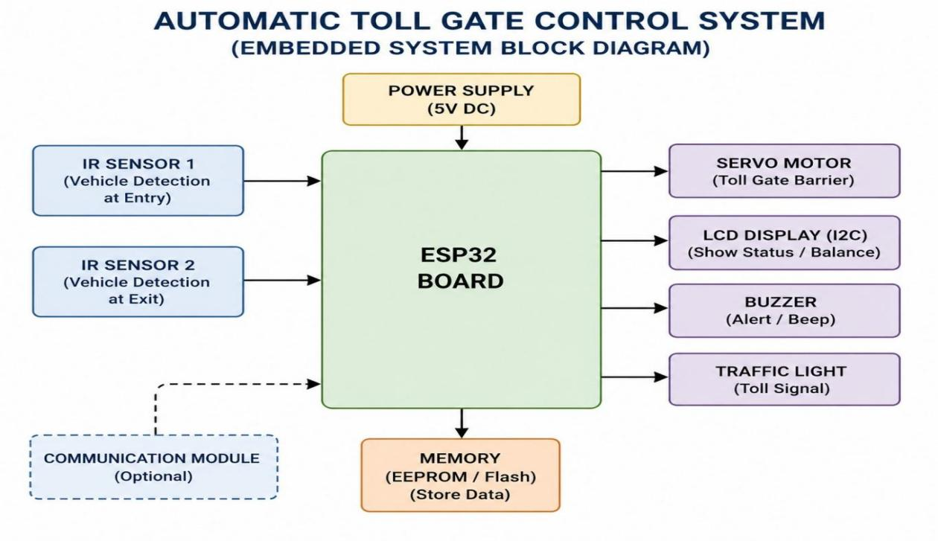
FIG[*]: Flow Chart of Automatic Toll Gate Control System

From FIG[*], once a vehicle approaches the toll gate, the operation proceeds through the following stages:
• Vehicle Detection: The IR sensor detects the presence of a vehicle and sends a signal to the ESP32 controller.
• Processing and Decision Making: The ESP32 processes the sensor input and determines whether the barrier gate should be opened.
• Gate Operation: The servo motor receives control signals from the ESP32 and opens the barrier gate, allowing the vehicle to pass.
• Monitoring and Status Update: The system updates the web dashboard with the current gate status and vehicle movement information in real time.
• Gate Closure: After the vehicle exits the detection zone, the ESP32 commands the servo motor to close the barrier gate automatically.
In this project, Aurdino IDE serves as the primary development environment where the ESP32 firmware and web monitoring functions are developed and tested. The Arduino IDE is used to compile and upload the program to the ESP32 microcontroller. Once the system is operational, the web dashboard is used to monitor sensor readings, gate status, and vehicle activity. This workflow enables efficient development, testing, and validation of the automatic toll gate control system while ensuring reliable hardware and software integration.

VI. EXPERIMENTAL RESULTS AND CONCLUSION

We tested the Automatic Toll Gate Control System and observed that the system operates reliably under normal conditions. The ESP32 successfully processes sensor inputs, controls the servo motor, and updates the monitoring dashboard in real time. The system accurately detects vehicle movement and performs automatic gate operations without manual intervention. A limitation of the current implementation is that it operates as a prototype and does not include advanced features such as RFID-based toll collection, online payment processing, or cloud-based data storage.
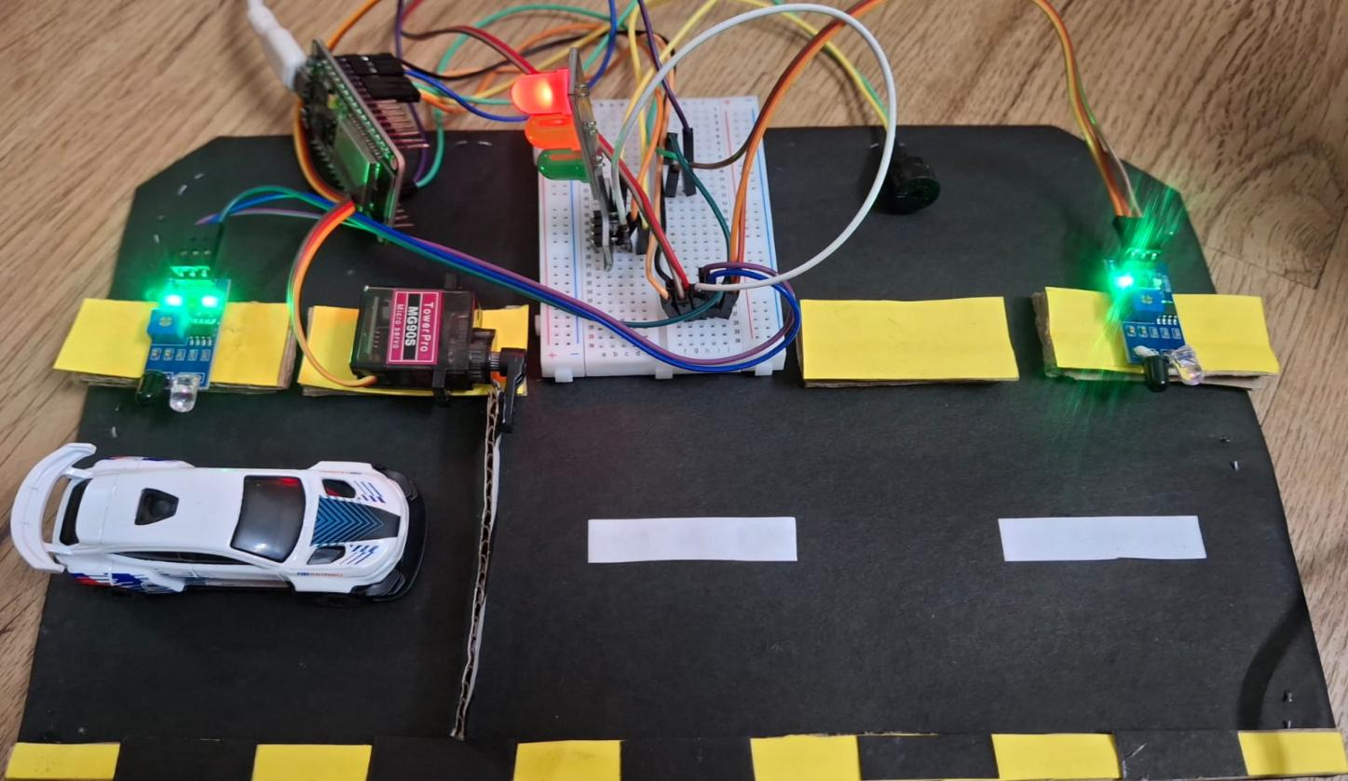
Fig. [1]. Automatic Toll Gate Control System
Figure 1 shows the hardware prototype of the Automatic Toll Gate Control System. The prototype consists of an ESP32 microcontroller, IR sensors, a servo motor, and a barrier gate mechanism. The IR sensors detect vehicle movement at the entry and exit points, while the ESP32 processes the sensor data and controls the gate operation. The prototype demonstrates the successful integration of hardware components required for automated toll gate management. 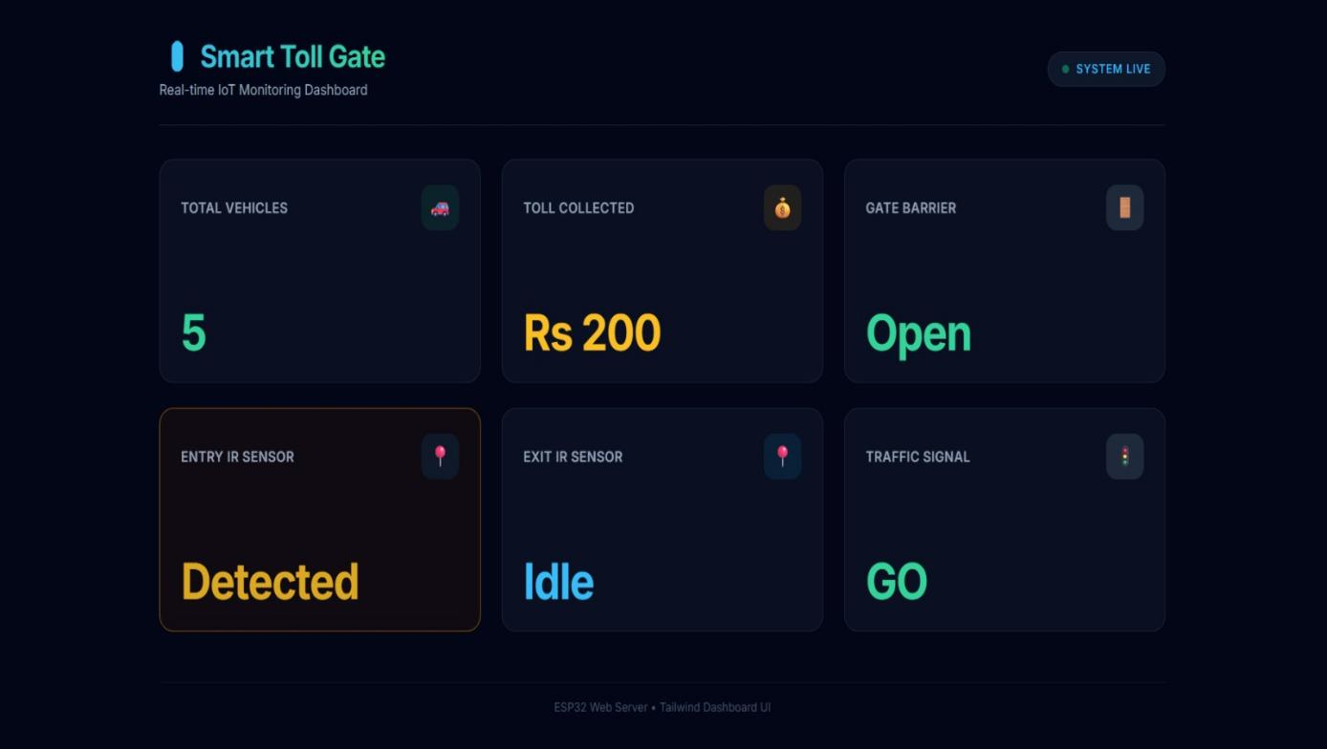
Fig. [2]. Real-Time Monitoring Dashboard
Figure 2 shows the real-time monitoring dashboard of the Automatic Toll Gate Control System. The dashboard displays information such as vehicle detection status, gate position, and overall system activity. Data is transmitted from the ESP32 through Wi-Fi communication and displayed on the web interface in real time. The dashboard enables administrators to monitor toll gate operations remotely and observe system performance. The successful display of live status updates confirms the effectiveness of the IoT-based monitoring framework implemented in the project.

VII. FUTURE SCOPE
The future of Automatic Toll Gate Control Systems lies in the integration of advanced technologies such as RFID, Automatic Number Plate Recognition (ANPR), artificial intelligence, and cloud computing. RFID-based toll collection and digital payment systems can further reduce vehicle waiting times and eliminate manual transactions. AI-powered traffic analysis can help optimize vehicle flow, predict congestion, and improve toll plaza efficiency. Cloud-based monitoring and data storage solutions will enable centralized management and real-time access to toll operation data from multiple locations.

VIII. CONCLUSION
The Automatic Toll Gate Control System utilizes ESP32, IR sensors, servo motor technology, and IoT communication to automate toll gate operations. The system detects vehicles, controls barrier movement, and provides real-time monitoring through a web-based dashboard. During implementation and testing, the system demonstrated reliable vehicle detection, automated gate control, and efficient monitoring capabilities. The project serves as a practical example of how embedded systems and IoT technologies can be applied to modern transportation infrastructure.
The proposed system reduces manual intervention, improves traffic flow, and enhances operational efficiency at toll plazas. It also provides a strong foundation for future developments in smart transportation and intelligent traffic management. With enhancements such as RFID-based toll collection, online payment integration, cloud connectivity, and AI-driven traffic analytics, the system can evolve into a comprehensive smart toll management solution suitable for large-scale deployment.

IX. ACKNOWLEDGEMENT

The authors would like to express their sincere gratitude to everyone who contributed to the successful development of the Automatic Toll Gate Control System. We are especially thankful to our project guide, faculty members, and department staff for their valuable guidance, encouragement, and technical support throughout the project. Their suggestions and feedback helped improve both the hardware and software components of the system.

X. REFERENCES

[1] R. Karthik and S. Muthukumar, “Automatic Toll Gate Control System Using RFID and Embedded Systems,” International Journal of Innovative Research in Science, Engineering and Technology, vol. 5, no. 3, pp. 34–40, 2020.
[2] P. Sharma and N. Yadav, “Design of Microcontroller-Based Toll Collection System Using IR Sensors,” International Journal of Electronics and Communication Engineering, vol. 7, no. 2, pp. 55–61, 2020.
[3] M. Anand and V. Suresh, “RFID-Based Automated Toll Plaza Management System,” IEEE Access, vol. 8, pp. 102345–102354, 2020.
[4] S. Kulkarni and A. Patil, “Smart Toll Collection Using Arduino and RFID Technology,” International Journal of Scientific Research in Computer Science, vol. 9, no. 1, pp. 22–28, 2021.
[5] T. Reddy and K. Prasad, “Embedded System-Based Vehicle Detection and Gate Control at Toll Booths,” International Journal of Advanced Research in Electrical, Electronics and Instrumentation Engineering, vol. 10, no. 4, pp. 78–85, 2021.
[6] A. Singh and R. Verma, “IoT-Enabled Automatic Toll Gate System with Real-Time Monitoring,” International Journal of Engineering Research & Technology, vol. 10, no. 6, pp. 145–151, 2021.
[7] B. Narayanan and C. Mohan, “Servo Motor Controlled Barrier Gate System Using 8051 Microcontroller,” International Journal of Embedded Systems and Applications, vol. 12, no. 3, pp. 11–19, 2021.
[8] H. Patel and D. Shah, “Automatic Number Plate Recognition for Toll Gate Automation,” IEEE Transactions on Intelligent Transportation Systems, vol. 23, no. 2, pp. 1120–1130, 2022.

